1-17-2025

Subject: Bowling Green KY featured on one of the top Travel TV Shows in the World!

With a newly inspired sense of belonging from our recently released Global Child Bowling Green Kentucky video (~1hr) accessible from the following link: <https://www.wku.edu/innovation/global_child_bg/> we are excited to share with you a flyer and QR code (see below) that links to our video. You are welcome to use one or both at your discretion, in flyers, posters, marketing materials, emails, suffixes, business cards, etc.; or just send it to friends and family. The QR code was created by the WKU Innovation Campus and links to the full episode of the show available for free on Tubi, a free streaming service. Again, this flyer and QR code is yours to use and share with others.

In an effort to reinforce the local philanthropy that brought us this incredible opportunity and highlights the true compassion of Bowling Green, we would love to amplify our efforts to positively impact our local charities and inspire people to get more involved. Such as:

The Foundry (featured in the Global Child BG episode): <https://thefoundrybg.org/>

Boys and Girls Club: <https://www.bgcbg.org/>

Kids on the Block: <https://kykob.org/>

St. Gianna: <https://www.stgiannacph.org/>

Curbside Ministries: <https://www.curbsideministries.com/>

and others as well.

On that note, we would like to invite you, your business associates, family and friends to a free public viewing of this hour-long show at Crossland Church’s auditorium at 600 US 31W By Pass, Fairview Shopping Center, Bowling Green KY. The show’s date/times are February 1st at 2pm, 4pm and 6pm Central Time. Tickets(free) are available at <https://globalchildbg.eventbrite.com/>. Augusto Valverde and his team will give a live presentation & QA after the viewing(s) during which they will acknowledge our founding sponsors, show participants and any **new** donors who give at least $5K to our show’s featured charity “The Foundry”. If you are interested in that level of donation to The Foundry or have any questions, feel free to contact me at: [buddy.steen@wku.edu](mailto:buddy.steen@wku.edu). Donation to The Foundry or not, please join us on February 1st. We are expecting a big turn-out, make sure to reserve your seat at: <https://globalchildbg.eventbrite.com/>

Note: 10 minute segments of this show over the past 22 days have been viewed by over 16.3 million people in 65 of the major US airports; and it will continue in the airports for the next month. The full episode will remain on Tubi and other streaming services permanently.

To learn more about Global Child TV click on this link: <https://vimeo.com/globalchildtv/pressreel>

The trailer for Global Child Kentucky (Bowling Green) is available with this link: <https://vimeo.com/globalchildtv/bowlinggreentrailer?share=copy>

The full Episode of Global Child Kentucky (Bowling Green), Episode 3 Now streaming live with FOX on TUBI can be accessed by this link: <https://www.wku.edu/innovation/global_child_bg/>

Compassion is truly the key!

Thanks,

Henry “Buddy” Steen (a new Global Child)

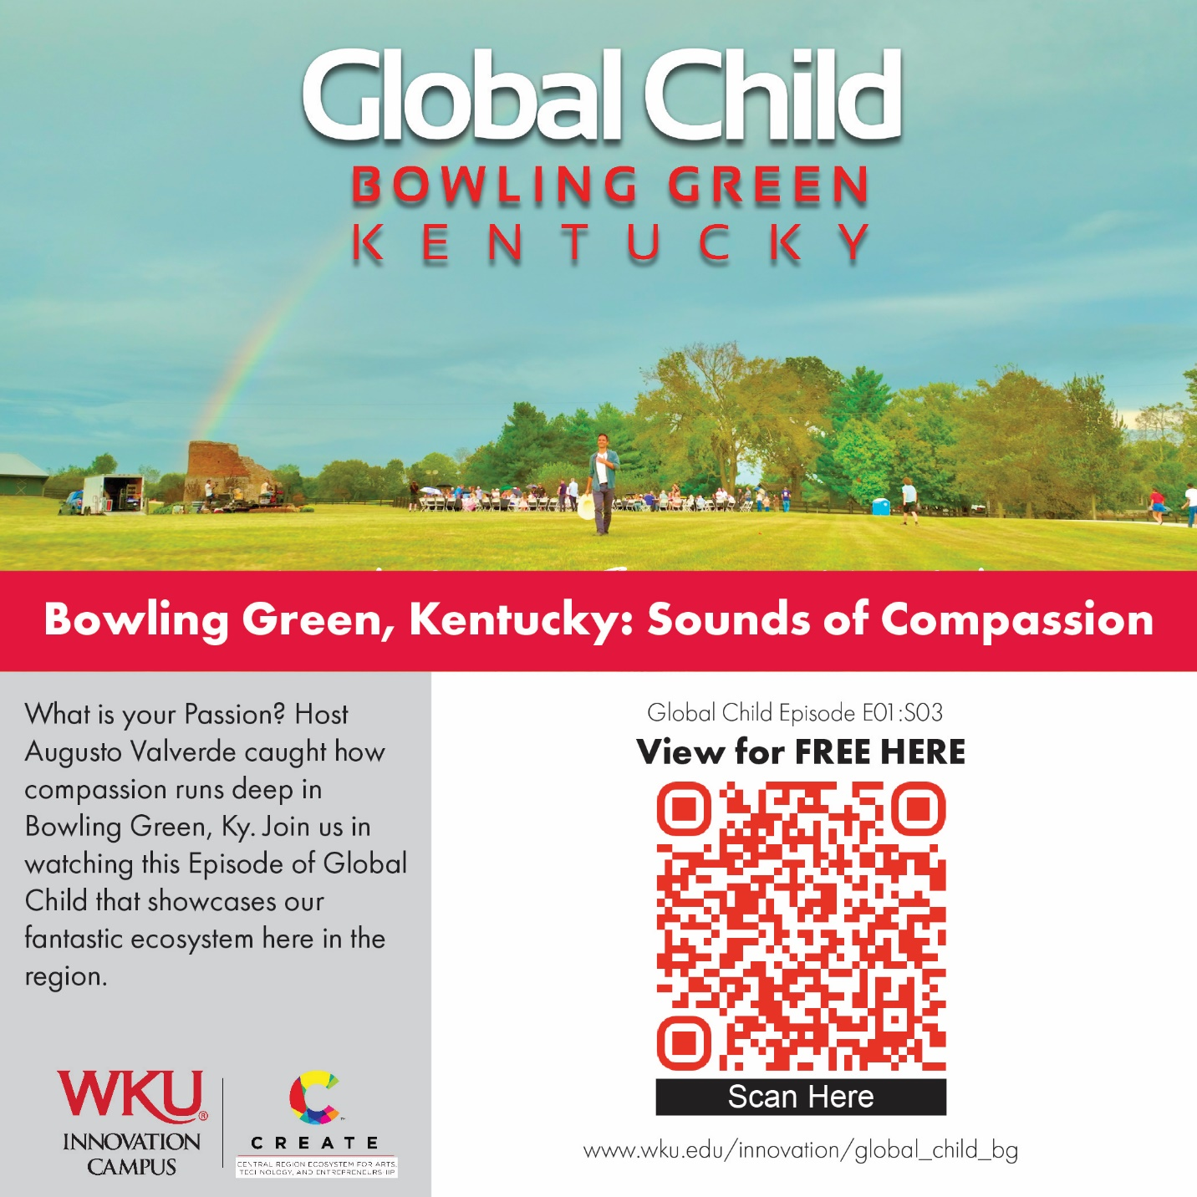

In case you want to use the QR code link by itself, here it is.

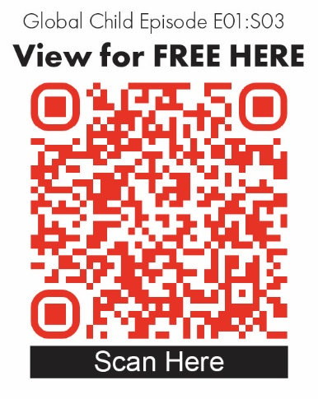

Thoughts for you from ChatGTP on ways to distribute the video’s QR code link and maximize its impact:

**1. Local Partnerships**

* **Businesses:** Partner with local businesses like cafes, restaurants, and shops to display the QR code on menus, receipts, or posters near checkouts.
* **Schools and Universities:** Collaborate with schools and universities to share the QR code with students, faculty, and staff.
* **Healthcare Facilities:** Place the QR code in hospitals, clinics, and community health centers, emphasizing the philanthropy and pre/postnatal support showcased in the video.

**2. Community Events**

* **Festivals and Gatherings:** Distribute the QR code at local events like farmer’s markets, cultural festivals, and sports events.
* **Charity Events:** Include the QR code on materials for charity events, emphasizing its connection to local philanthropy.

**3. Digital Distribution**

* **Social Media Campaigns:** Share the QR code on platforms like Facebook, Instagram, and Twitter, with a call-to-action (CTA) emphasizing compassion and giving back.
* **Local Influencers:** Partner with regional influencers to share the QR code and talk about the show.
* **Email Newsletters:** Include the QR code in newsletters sent out by community organizations, businesses, and nonprofits.

**4. Physical Distribution**

* **Posters and Flyers:** Place posters with the QR code in high-traffic areas like libraries, community centers, gyms, and grocery stores.
* **Transit Advertising:** Include the QR code on local buses, benches, or in rideshare vehicles.
* **Billboards:** Use strategically placed billboards to encourage scanning.

**5. Tech Integration**

* **Wi-Fi Landing Pages:** Partner with public Wi-Fi providers to show the QR code on their login pages in places like coffee shops or public parks.
* **Digital Signage:** Display the QR code on screens in local malls, movie theaters, or other high-visibility locations.

**6. Tourism Channels**

* **Welcome Centers:** Place the QR code at visitor centers and hotels, promoting it as a resource for discovering Bowling Green.
* **Travel Guides:** Partner with regional travel publications and websites to include the QR code in their materials.

**7. Workplace Engagement**

* **Corporate Partnerships:** Share the QR code with local employers and ask them to distribute it to their employees as part of a community initiative.
* **Lunch-and-Learn Sessions:** Organize short presentations in workplaces about the video and the causes it supports, encouraging employees to scan the QR code.

**8. Creative Campaigns**

* **Giveaways and Contests:** Offer small incentives or entry into a drawing for those who scan the code and watch the video.
* **Interactive Displays:** Create an engaging physical display at a local landmark that incorporates the QR code and invites curiosity.

**9. Media Outreach**

* **Local Press:** Collaborate with local newspapers, radio stations, and TV channels to feature stories about the video and include the QR code in their coverage.
* **Airport Integration:** Ensure that the QR code is promoted alongside the show in airports to further its reach.

**10. Charity Integration**

* **Nonprofit Collaboration:** Partner with nonprofits to distribute the QR code during their events or as part of their outreach materials.
* **Donation Drives:** Include the QR code in donation campaigns, highlighting the philanthropic message of the show.

**11. Incentivize Engagement**

* Offer discounts or coupons at local businesses for those who scan the QR code and engage with the video.

By combining these methods and tailoring them to Bowling Green’s specific audience and culture, you can maximize the QR code's impact and amplify the compassionate spirit of the community.